# **User Scenarios/Use Cases**

* 1. **User Scenarios:**

**Client**

**S_U1 Client is not logged in**

1. Client can see all products available for sale
2. Client can see all products out of stock at the moment (if they’re still up on the site)
3. Client can access the helper AI
4. Client can start the registration process or sign in to an existing account
5. Client can see the technician services offered but cannot make appointments
6. Client can see a timeline of previous giveaways/events but cannot become part of the upcoming ones

**S_U2 Client is registering**

1. Client clicks on the “registration” button
2. Client provides the requested information (name, contact information, payment options)
3. Client adds a password
4. Client clicks “Complete”

**S_U3 Client is signing in**

1. Client clicks on the “sign in” button
2. Client enters their username and password
3. If they do not recall their password they click the “forgot my password” button and receive a new temporary password in their email
4. Client clicks the “Ok” button

**S_U4 Client is signed in**

1. Client can see all products available
2. Client can see all products currently out of stock
3. Client can request personalization’s
4. Client can request appointments with technicians
5. Client can enter giveaways
6. Client can try to join events
7. Clients can talk to customer service
8. Client can leave reviews on products or staff

**S_U5 Client adding to cart**

1. Client chooses the products they like
2. Client clicks the “add to cart” button
3. Client is shown items other clients have often bought along with said product

**S_U6 Client checking out**

1. Client finishes adding products to cart
2. Client clicks the “Your Cart” button
3. Client rechecks if they want to buy all the products in the cart
4. Client is asked to confirm their postal address
5. Client is presented a window with the total amount to be paid and is asked if they wish to proceed with making the payment with the card linked on their account
6. If the payment is confirmed the client will be informed on the date the items are expected to arrive, otherwise they’re asked to provide another payment method. If no such method is provided the client will be returned to their “Your Cart” menu

**US7: Entering Giveaways**

1. Client will be presented with the product/s in giveaway as soon as entering the site.  
2. Client can see the details on the giveaway such as the timeframe of applying and end-date.  
3. If not already, client needs to go through the process of signing up with his/her personal information to then be able to enter the giveaway.  
4. Client needs to click “Enter giveaway”.  
5. Client needs to fulfill all listed requirements before officially being part of the giveaway.  
6. Client clicks “Complete”.

**US8: Making Custom Orders**

1. Client will be presented with “custom orders” page when entering the site.  
2. The page will display all brands the shop has partnership with and that offer the custom order option.  
3. When interacting with a brand, it will show all available options for personalization.  
4. Client can select different options for the selected base instrument such as material (wood types, plastic, carbon fiber), color, string types (guitar, piano, violin, cello), pickups(guitars), tiles(pianos) and so on, where each special part is added to the overall price of the instrument.  
5. Upon finishing the custom order, if the client is not logged in already, they are obliged to so the order can be completed.  
6. The item is added to cart and the client can continue with the check-out process.

**US9: Setting up appointments**

1. Client will be presented with “Technical Support” page as soon as entering the site.  
2. The page will display alternatives of technical support depending on your instrument (guitar tech-guy will not be the same as the piano or drum tech-guy) or sound system.  
3. Upon selecting the specific tech-support, their calendar of appointments will be shown, displaying the hours/days they are free to set up an appointment or are busy with other customers.  
4. The customer can select an hour/day for an appointment and click “Confirm Appointment” to finalize it.

5. If the client is not logged in already, they need to log in before the appointment is finalized.  
6. Client needs to provide their personal client details in the site to the tech-support upon meeting them so the service can proceed.  
7. Upon the instruments fixing/upgrade, a notification is sent to the client via their contact information, along with the bill that can be paid immediately at the shop upon instrument pickup or via the customer account online.

**US10: Contacting customer service**

1. Client will be presented with “Customer Service” page as soon as entering the site.  
2. Upon entering the page, a wide variety of issues that customers usually have will be displayed to the client.  
3. Client must be logged in if the concern is regarding one of their orders, personalization’s, participations in events or giveaways and other issues with personal client information.  
4. When clicking one of these issues, depending on their complexity, the links can either redirect the client to an automated AI with the answers or to workers of the shop (having a hard time logging in can be supported by an AI that walks the client through the process rather than consuming the time of the worker that might deal with something much more complex).  
5. Client can state their own issues not displayed in the general tab via the option “Other”.  
6. In cases of contacting the workers, clients can either wait for their response online in the site or be notified via their contact information provided from their account.

**US11: Leaving a review**

1. Client needs to be logged in to leave a review.  
2. The option “leave a review” will appear after purchasing a product, receiving customer service, attending an event, or receiving technical support.  
3. After clicking the option, the client can leave a “star-rating” and write their review on the item, service or event including a header and their detailed message.  
4. Reviews will be public to all other customers and staff and will be taken under consideration for a better experience.  
5. Foul or offensive comments in reviews will immediately take the entire review down and the customer dealt with depending on the scale of issue.

**S_U12 Shopkeeper is signing in**

1. Shopkeeper clicks on the "sign in" button
2. Shopkeeper enters their username and password
3. If they do not recall their password, they click the "forgot my password" button and receive a new temporary password in their email
4. Shopkeeper clicks the "Ok" button.

**S_U13 Shopkeeper is adding an item**

1. Shopkeeper clicks on the "add item" button.
2. Shopkeeper provides the requested information: required -> name, image, item code, quantity, unit price, supplier information, purchase order number, date of purchase, location in the warehouse, expiration (if needed). optional -> description, weight, dimensions.
3. Shopkeeper clicks "Complete" button.

**S_U14 Shopkeeper is updating an item**

1. Shopkeeper opens the wanted item page.
2. Shopkeeper clicks on the "Edit" button.
3. Shopkeeper makes changes to the item's information.
4. Shopkeeper clicks "Complete" button.
5. Shopkeeper is prompted to confirm their changes.

**S_U15 Shopkeeper is communicating with client**

1. Shopkeeper will be presented with "Online Customers Waiting For Help" page as soon as entering the site, if none are waiting they will be presented with the contact information of clients requesting assistance.
2. Once connected with the client, shopkeeper will give continuous answers to the questions of the client.
3. When the information is received and the conversation is finished, the interaction will be recorded and saved.

**S_U16 Shopkeeper is managing giveaways**

1. Shopkeeper clicks on the "create giveaway" button.
2. Shopkeeper creates a plan for the giveaway, including the item or items to be given away, the quantity of items, and the timeframe for the giveaway.
3. As customers open the software, the system informs them of the giveaway and provides them with the necessary information about how to participate.
4. Shopkeeper evaluates the success of the giveaway by reviewing the participation rates, customer feedback, and any other relevant metrics, and saves this information to inform future giveaways or promotional activities.

**S_U17 Shopkeeper is accepting personalizations:**

1. Shopkeeper discusses the details of the personalization with the customer,including the desired design, size, placement, and any other relevant specifications.
2. Shopkeeper clicks on "add personalized item" button
3. Shopkeeper creates an order for the personalized product and enters the customer's information, including their name, contact information, and payment details.
4. Shopkeeper clicks on "forward to vendor" button
5. In the list of vendors, shopkeeper will click the appropriate one.
6. Shopkeeper will click "forward order" button.
7. Shopkeeper adds the item to the system.
8. When the item is ready, shopkeeper contacts the customer to let them know that their personalized product is ready for pickup or shipping.
9. After item is picked up, shopkeeper updates the item in the system.

**S_U18 Technician is signing in**

1. Technician clicks on the "sign in" button.
2. Technician enters their username and password.
3. If they do not recall their password, they click the "forgot my password" button and receive a new temporary password in their email.
4. Technician clicks the "Ok" button.

**S_U19 Technician is adding dates/hours available**

1. Technician logs into their scheduling system using their credentials.
2. They navigate to the "Availability" section of the system.
3. Technician selects the dates they are available to work from the calendar and marks them as available.
4. They enter the hours they are available to work on each day.
5. Technician clicks on the "Save" button to add their availability to the system.

**S_U20 Technician is accepting appointments**

1. Technician logs into their scheduling system using their credentials.
2. They navigate to the "Appointments" section of the system.
3. Technician sees a list of available appointments and selects the one they want to accept.
4. They click the "Accept" button to confirm the appointment or "Reject" button to decline it. If they choose to reject the appointment ,the system will remove it from their calendar and notify the costumer.
5. The appointment is added to their calendar and the customer is notified.

**S_U21 Admin is signing in**

1. Admin enters their username and password
2. If they do not recall their password, they click the "forgot my password" button and receive a new temporary password in their email
3. Admin clicks the "Ok" button.

**S_U22 Admin is adding an item**

1. Admin clicks on the "add item" button.
2. Admin provides the requested information: required -> name, image, item code, quantity, unit price, supplier information, purchase order number, date of purchase, location in the warehouse, expiration(if needed). optional -> description, weight, dimensions.
3. Admin clicks "Complete" button.

**S_U23 Admin is modifying an item**

1. Admin opens the wanted item page.
2. Admin clicks on the "Modify" button.
3. Admin makes changes to the folder.
4. Admin clicks "Complete" button.
5. Admin is prompted to confirm their changes.

**S_U24 Admin is seeing data on sales**

1. Admin clicks on "Sales" button.
2. Admin checks the data on sales.

**S_U25 Admin is organizing giveaways**

1. Admin clicks on the "organize giveaway" button.
2. Admin buys the items needed for the giveaway.
3. Admin sends the items to the store.

**S_U26 Admin is organizing events**

1. Admin clicks on the "create event" button.
2. Shopkeeper creates a plan for the event, including the artist or artists performing, and the timeframe for the event.
3. As customers open the software, the system informs them of the event and provides them with the necessary information.
4. Event evaluates the success of the event by reviewing the participation rates, customer feedback, and any other relevant metrics, and saves this information to inform future artists or events.

**S_U27 Admin is seeing data on staff**

1. Admin clicks on the "Staff" button.
2. Admin can see the data all staff members.

**S_U28 Admin is seeing reviews**

1. Admin clicks on the "Review" button.
2. Admin checks the reviews of the shop.
   1. **Use cases**

**Use case nr 1 Signed in Client**

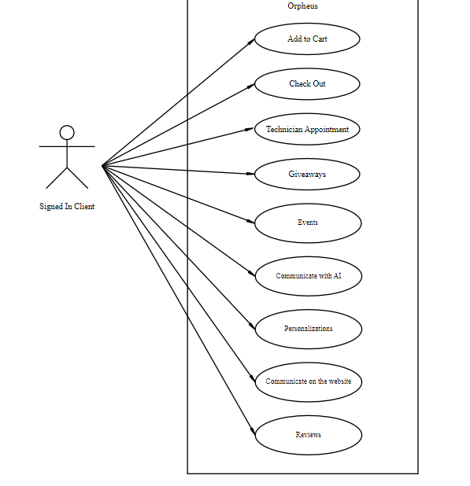

**Use case 2 Not Signed in Client**

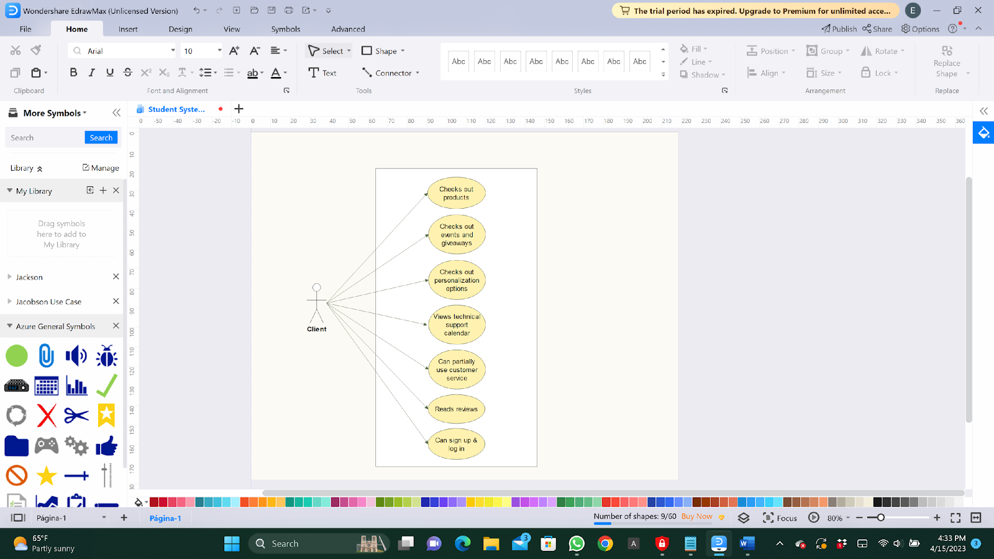

**Use case nr 3: Shopkeeper**

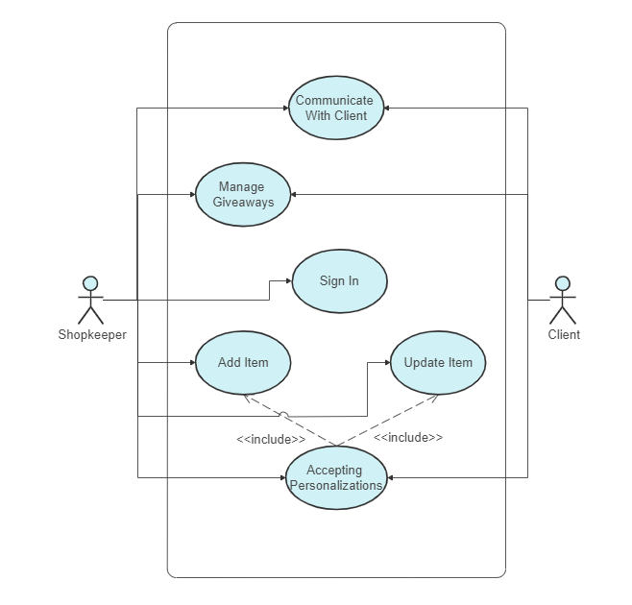

**Use case nr 4 Technician**

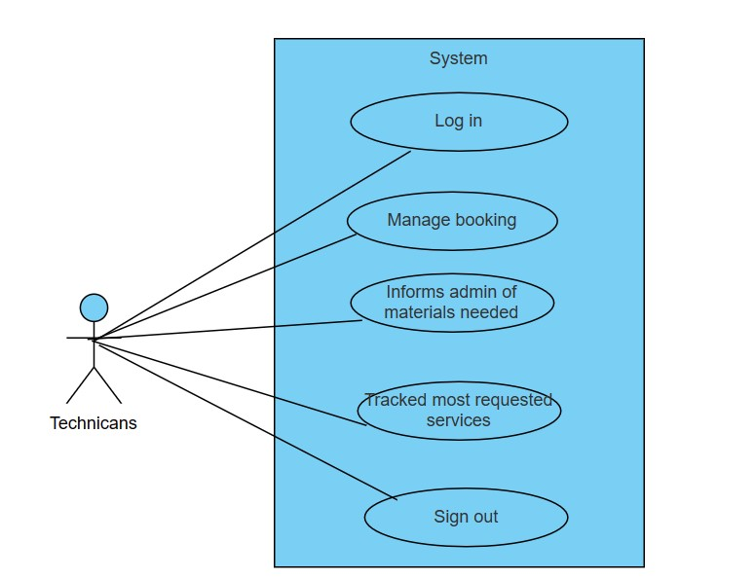

**Use case nr 5 Music Guest**

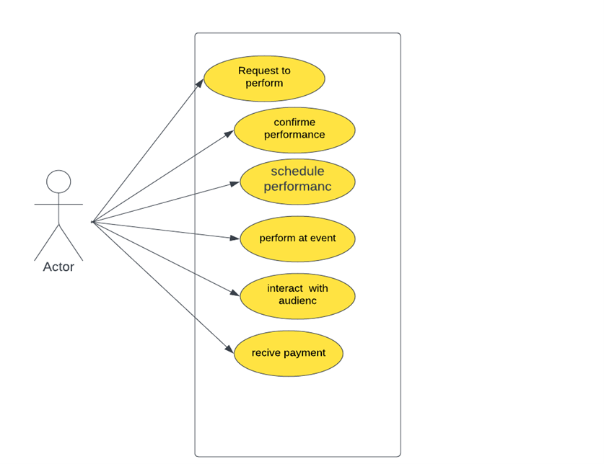

**Use case nr 6 Admin**

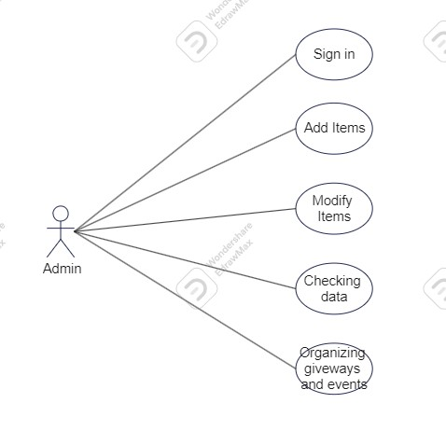

**Use case nr 7 General**

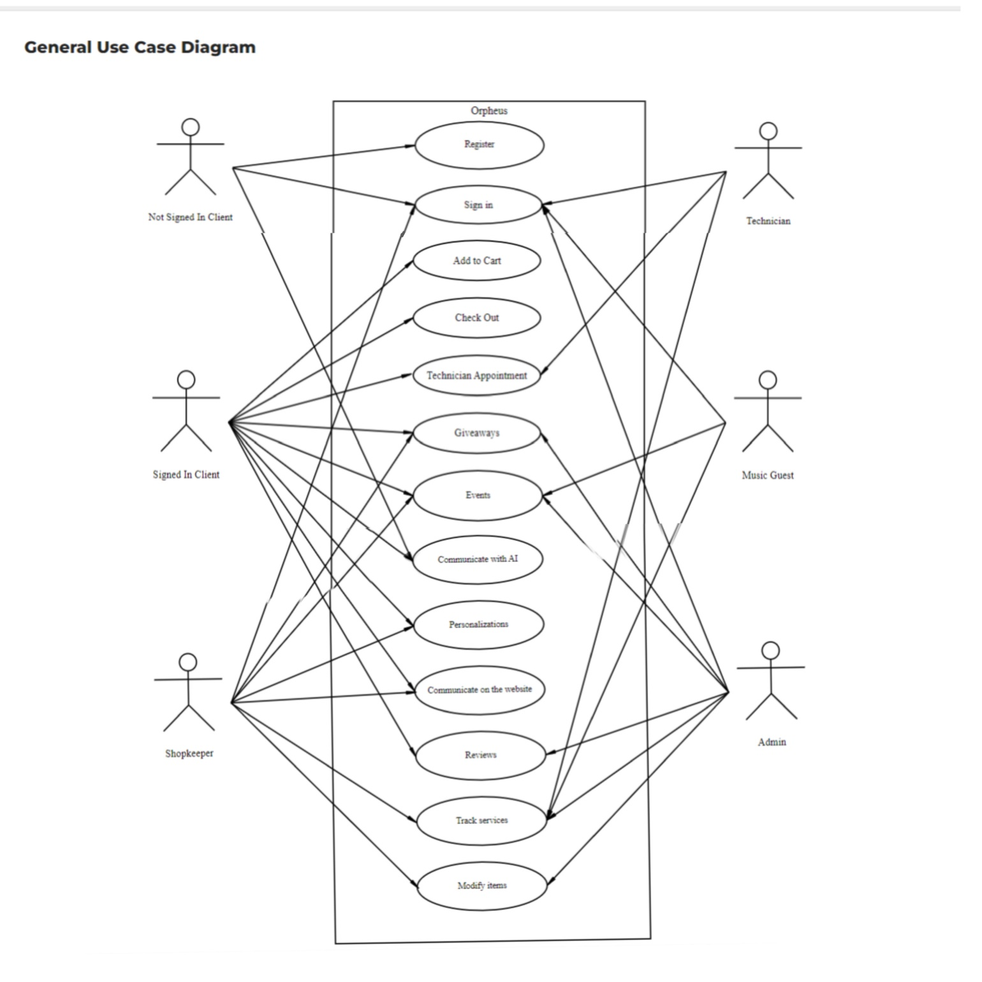

* 1. **Use case expanded**

|  |  |
| --- | --- |
| Use case 1.1: | client SIgning in |
| Scope | Music shop app |
| Level | User level |
| Intention Context | Client needs to sign in in order to access all the features of the website and talk directly to customer service |
| Minimum guarantees | Client will enter the data but will not be able to sign in |
| Success guarantees | Client will be able access all the features and services the website offers |
| Primary actor | Client |
| Stakeholder’s interest | Clients being able to actually buy products, therefore bring in income |
| Preconditions | The client needs to have already signed up beforehand |

|  |  |
| --- | --- |
| Use case 1.2: | client CHECKS OUT ITEMS |
| Scope | Music shop app |
| Level | User level |
| Intention Context | Client observes all items or services that might be of interest |
| Minimum guarantees | Client will observe all products in stock or not, as well as other services without taking other action |
| Success guarantees | Client will observe all products and services and take other action (such as adding to cart or booking appointments) |
| Primary actor | Client |
| Stakeholder’s interest | Clients being tempted to buy products or services |
| Preconditions | The client must be signed in |

|  |  |
| --- | --- |
| Use case 1.3: | client ADDS TO CART |
| Scope | Music shop app |
| Level | User level |
| Intention Context | Client progresses with the intent to purchase items |
| Minimum guarantees | Client cannot add out of stock items to cart |
| Success guarantees | Client adds items to cart and will then proceed to the checkout portion |
| Primary actor | Client |
| Stakeholder’s interest | Clients being about to spend money on products |
| Preconditions | The client must be signed in and have observed the items |

|  |  |
| --- | --- |
| Use case 1.4: | client proceeds to check out |
| Scope | Music shop app |
| Level | User level |
| Intention Context | Client will pay for the afore selected products |
| Minimum guarantees | Client will not be charged if they do not click confirm order |
| Success guarantees | Client will click confirm order and then be charged |
| Primary actor | Client |
| Stakeholder’s interest | Clients being tempted to buy products or services |
| Preconditions | The client must have added products to cart |

|  |  |
| --- | --- |
| Use case 1.5: | client confirms the arrival of their order |
| Scope | Music shop app |
| Level | User level |
| Intention Context | Client confirms the arrival of the delivery |
| Minimum guarantees | Client will confirm the fact they have paid but not the fact they have received the package |
| Success guarantees | Client will confirm both the fact they paid and the arrival of their package |
| Primary actor | Client |
| Stakeholder’s interest | Client is content and as such is likely to buy again |
| Preconditions | The client must have ordered and paid the product |

|  |  |
| --- | --- |
| Use case 1.6: | client enters giveaways |
| Scope | Music shop app |
| Level | User level |
| Intention Context | Client enters a contest with the intent to win free products/services |
| Minimum guarantees | Client will observe current giveaways but will not enter in any |
| Success guarantees | Client will observe current giveaways and will enter successfully |
| Primary actor | Client |
| Stakeholder’s interest | Clients are motivated to check the application often |
| Preconditions | The client must be signed in |

|  |  |
| --- | --- |
| Use case 1.7: | client joins events |
| Scope | Music shop app |
| Level | User level |
| Intention Context | Client observes events (past, present and future) and decides to join one |
| Minimum guarantees | Client will be able to observe all events and will not join any of them |
| Success guarantees | Client will observe all events and join at least one |
| Primary actor | Client |
| Stakeholder’s interest | Clients spending more time in our website and around our staff |
| Preconditions | The client must be signed in |

|  |  |
| --- | --- |
| Use case 1.8: | client requests persoalizations |
| Scope | Music shop app |
| Level | User level |
| Intention Context | Client wants to personalize a musical instrument in their possession |
| Minimum guarantees | Client will fill all fields required but will not be able to progress to a further step |
| Success guarantees | Client will fill all fields required and will be able to progress to a further step |
| Primary actor | Client |
| Stakeholder’s interest | Clients paying for a service |
| Preconditions | The client must be signed in |

|  |  |
| --- | --- |
| Use case 1.9: | client books appointments |
| Scope | Music shop app |
| Level | User level |
| Intention Context | Client books appointments with specialized technicians to repair/check their instruments |
| Minimum guarantees | Client will be able to see the hours available of each technician but not be able to make a booking |
| Success guarantees | Client will be able to see all hours available of each technician and request an appointment |
| Primary actor | Client |
| Stakeholder’s interest | Clients paying for a service |
| Preconditions | The client must be signed in |

|  |  |
| --- | --- |
| Use case 1.10: | client communicate to customer service |
| Scope | Music shop app |
| Level | User level |
| Intention Context | Client talks to customer service in order to get a professional opinion in order to make a more educated purchase |
| Minimum guarantees | Client will send a message and not get a reply back |
| Success guarantees | Client will send a message and then have a conversation with a shopkeeper in order to make an educated purchase on the item most suited to them |
| Primary actor | Client |
| Stakeholder’s interest | Clients being informed and educated so more likely to return |
| Preconditions | The client must be signed in |

|  |  |
| --- | --- |
| Use case 1.11: | client leaves reviews |
| Scope | Music shop app |
| Level | User level |
| Intention Context | Client expresses their opinion on products/staff/website |
| Minimum guarantees | Client will see they can write a review but elect to ignore it |
| Success guarantees | Client will write out their review and post it |
| Primary actor | Client |
| Stakeholder’s interest | Being able to see the levels of customer satisfaction |
| Preconditions | The client must be signed in |

|  |  |
| --- | --- |
| Use case 1.12: | client signs out |
| Scope | Music shop app |
| Level | User level |
| Intention Context | Client signs out in order to protect their privacy |
| Minimum guarantees | Client will be able to see the “Sign out” button but nothing happens when its clicked |
| Success guarantees | Client will be able to sign out when the “Sign out” button is clicked |
| Primary actor | Client |
| Stakeholder’s interest | Clients being content so they do not mind using the website |
| Preconditions | The client must be signed in |

|  |  |
| --- | --- |
| Use case 2.1: | Guest client checks out events/giveaways |
| Scope | Music shop app |
| Level | User level |
| Intention Context | Client can see the events or giveaways happening in the near future |
| Minimum guarantees | Client will not be able to get enough information about the events/giveaways |
| Success guarantees | Client will be informed about the general information of events/giveaways, but cannot participate without an account |
| Primary actor | Guest client |
| Stakeholder’s interest | Guests are drawn to future activities, so they log in and apply for participation |
| Preconditions | The guest client must have entered the app and clicked on the “events” category |

|  |  |
| --- | --- |
| Use case 2.2: | Guest client checks out personalization options |
| Scope | Music shop app |
| Level | User level |
| Intention Context | Client can see options of personalizing/upgrading their instruments |
| Minimum guarantees | Client will not be able to get the entire range of personalization option information |
| Success guarantees | Client will be informed about the general information on personalizing or making custom orders, but cannot purchase them without an account |
| Primary actor | Guest client |
| Stakeholder’s interest | Guests are drawn to the wide range of personalization options and custom orders, pushing them to create accounts and make purchases |
| Preconditions | The guest client must have entered the app and clicked on the “custom orders” category |

|  |  |
| --- | --- |
| Use case 2.3: | Guest client views technical support calendar |
| Scope | Music shop app |
| Level | User level |
| Intention Context | Client can check out the free dates of technician’s schedule to set up a meeting to fix or upgrade their instruments |
| Minimum guarantees | Client will not be able to find a free date that the technician is available |
| Success guarantees | Client will be able to find a free date to meet the technician, but cannot confirm the meeting without an account |
| Primary actor | Guest client |
| Stakeholder’s interest | Guests can see the availability of the technicians; they hurry to occupy free dates by creating accounts and confirming meetings |
| Preconditions | The guest client must have entered the app and clicked on the “tech support” category |

|  |  |
| --- | --- |
| Use case 2.4: | Guest client partially uses customer service |
| Scope | Music shop app |
| Level | User level |
| Intention Context | Client can ask questions to customer service about their issues |
| Minimum guarantees | Client will get general answers from the AI that may or may not be helpful |
| Success guarantees | Client will get general answers from the AI or worker, but cannot ask specific questions without an account |
| Primary actor | Guest client |
| Stakeholder’s interest | Guests want to ask more specific questions about their issues, so they create accounts and increase interactivity with the app |
| Preconditions | The guest client must have entered the app and clicked on the “customer service” category |

|  |  |
| --- | --- |
| Use case 2.5: | Guest client checks out reviews on products |
| Scope | Music shop app |
| Level | User level |
| Intention Context | Client can read the public reviews listed under the products |
| Minimum guarantees | Client will find only star ratings listed below the product they are interacting with |
| Success guarantees | Client will read many reviews from other logged in clients, but cannot leave one themselves without an account |
| Primary actor | Guest client |
| Stakeholder’s interest | Guests read reviews and are tempted to ask questions to other reviewers before buying the product, so they create accounts and increase interactivity with the app |
| Preconditions | The guest client must have entered the app and clicked on the preferred product to then read the reviews |

|  |  |
| --- | --- |
| Use case 2.6: | Guest client can sign up or log in |
| Scope | Music shop app |
| Level | User level |
| Intention Context | Client can create a personal account and log in with that account |
| Minimum guarantees | Upon signing up other existing account problems can occur; upon logging in there can be issues with forgotten emails or passwords |
| Success guarantees | Client will create a new personal account and log in with that account |
| Primary actor | Guest client |
| Stakeholder’s interest | Guest clients will sign in, granting themselves a plethora of purchasing products and services, increasing income for the shop |
| Preconditions | The guest client must have a distinct email and password, not priorly used for another account in the app for the sign up to work |

|  |  |
| --- | --- |
| Use case 3.1: | SHOPKEEPER signs in |
| Scope | Music shop app |
| Level | User level |
| Intention Context | Shopkeeper signs in to his account to have accessibility to different actions |
| Minimum guarantees | Shopkeeper might face issues signing up because of other existing account, forgetting email or password |
| Success guarantees | Shopkeeper will create a new personal account and be able to log in with it |
| Primary actor | Shopkeeper |
| Stakeholder’s interest | Shopkeeper will have a wide variety of options specific to him/her, increasing effectivity and efficiency in business |
| Preconditions | Shopkeeper needs to have a distinct email and password not used before in the system and remember them each time he/she logs in |

|  |  |
| --- | --- |
| Use case 3.2: | SHOPKEEPER COMUNICATES WITH CLIENT |
| Scope | Music shop app |
| Level | User level |
| Intention Context | Shopkeeper can ask or answer different questions that the client places |
| Minimum guarantees | Shopkeeper will not be able to completely satisfy or fulfill the client with the information given |
| Success guarantees | Shopkeeper will be able to fully inform the client about the necessary information |
| Primary actor | Shopkeeper |
| Stakeholder’s interest | Shopkeeper gives enough information to the clients to guarantee further engagement be it by interest in events or placing orders |
| Preconditions | To communicate with client online the shopkeeper needs to be logged in by his personal account |

|  |  |
| --- | --- |
| Use case 3.3: | SHOPKEEPER Manages GIVEAWAYS |
| Scope | Music shop app |
| Level | User level |
| Intention Context | Shopkeeper can set up giveaway events with conditions as pleased |
| Minimum guarantees | Shopkeeper’s conditions for the giveaway will not be fulfilled by anyone and the giveaway will not be completed |
| Success guarantees | Shopkeeper will be able to set up a successful giveaway where participating clients are satisfied |
| Primary actor | Shopkeeper |
| Stakeholder’s interest | Shopkeeper can draw a big audience of clients to be interested in current and upcoming events increasing engagement |
| Preconditions | The shopkeeper needs to be logged in by his personal account, see the event agenda calendar and keep up with inventory and current trends |

|  |  |
| --- | --- |
| Use case 3.4: | SHOPKEEPER adds new item |
| Scope | Music shop app |
| Level | User level |
| Intention Context | Shopkeeper can add new product to the system for potential clients |
| Minimum guarantees | Shopkeeper might face issues adding it as new, either if the item is already in system or the item does not exist |
| Success guarantees | Shopkeeper will be able to add the item to the system for everybody to see |
| Primary actor | Shopkeeper |
| Stakeholder’s interest | Added item/product will draw in more clients and increase sales and interest |
| Preconditions | To add a new item the shopkeeper needs to be logged in by his personal account |

|  |  |
| --- | --- |
| Use case 3.5: | SHOPKEEPER updates existing item |
| Scope | Music shop app |
| Level | User level |
| Intention Context | Shopkeeper can change details about a product already in the system |
| Minimum guarantees | Shopkeeper might face issues locating the item in system or changing its attributes depending on the products variety |
| Success guarantees | Shopkeeper will be able to update the item in the system |
| Primary actor | Shopkeeper |
| Stakeholder’s interest | Updated product will draw in more clients and increase sales and interest (particularly sales, but also special deals or new specifics) |
| Preconditions | To update an item the shopkeeper needs to be logged in by his personal account |

|  |  |
| --- | --- |
| Use case 3.6: | SHOPKEEPER accepts personalization orders |
| Scope | Music shop app |
| Level | User level |
| Intention Context | Shopkeeper can confirm custom orders about products from clients |
| Minimum guarantees | Shopkeeper will postpone the custom order until the special parts are available for the instrument |
| Success guarantees | Shopkeeper will accept and confirm the order |
| Primary actor | Shopkeeper |
| Stakeholder’s interest | Custom orders tend to create a closer connection between clients and the instruments they order, increasing demand of product |
| Preconditions | To confirm a custom order the shopkeeper needs to be logged in by his personal account |

|  |  |
| --- | --- |
| Use Case 4.1: | Technician sign in |
| Scope: | Music shop app |
| Level: | Technician level |
| Intention Context: | The Technician need to sign in in this app in order to manage their bookings ,perform repair and maintenance work and update their account information. |
| Minimum Guarantees: | The system allows only authorized technicians with a valid id and password. |
| Success Guarantees: | The Technician is able to successfully sign in in to their account and access the Musician Store’s technician system. |
| Primary Actor: | Technician |
| Stakeholder’s Interest: | Technician wants to access the system to manage reservations and perform repair and maintenance work.  Musicians Store wants to ensure that only authorized technicians can access . |
| Precondition: | The technician has a valid sign in Id and password .  The technician has access to the Musician Store’s technician system. |

|  |  |
| --- | --- |
| Use Case 4.2: | Technician Manage Booking |
| Scope: | Music shop app |
| Level: | Technician Level |
| Intention Context: | The technician manages their bookings within the Musician Store’s technician system |
| Minimum Guarantees: | The system prevents double-booking and allows the Technician to view and manage current bookings ,and sends notifications to the technician If there are any changes to their bookings. |
| Success Guarantees: | Technician will be able to view and manage their current bookings .  They can receive notifications of any changes to their bookings.  The technician will be able to update status of their booking such as making a booking as completed or rescheduling a booking. |
| Primary Actor: | Technician |
| Stakeholder’s Interest: | Technician wants to manage their bookings and ensure that they are able to complete their repair.  Musician Store wants to avoid scheduling conflict and then wants to provide a good service to satisfy the customers |
| Precondition: | The technician is logged in to their account and has access to the technician system. |

|  |  |
| --- | --- |
| Use Case 4.3: | Technician informs admin of materials needed |
| Scope: | Music shop app |
| Level: | Technician level |
| Intention Context: | The Technician notifies the Admin of the materials needed to complete a repairs . |
| Minimum Guarantees: | The system provides a way for technician to notify the admin for the materials needed.  The system send notifications to the admin of any materials needed to complete a repair . |
| Success Guarantees: | The admin is notified of the necessary materials.  The system logs the request and updates the inventory system to ensure accurate tracking of materials needed. |
| Primary Actor: | Technician |
| Stakeholder’s Interest: | Technician wants to ensure if he has the necessary materials to complete repair.  The Admin it is necessary to inform if there is a need for additional materials or not |
| Precondition: | The technician has access to the Musician Store’s technician system and has the valid id and password.  The technician is currently working on repair.  Required materials are not available to the Technician. |

|  |  |
| --- | --- |
| Use Case 4.4: | Technician tracked most requested service |
| Scope: | Music shop app |
| Level: | Technician level |
| Intention Context: | The Technician tracks the most requested service by customers in the Musician Store’s technician system. |
| Minimum Guarantees: | The system display the most requested service by costumers in the technician system. |
| Success Guarantees: | Technician can view the most requested service and optimize inventory management and resource allocation accordingly . |
| Primary Actor: | Technician |
| Stakeholder’s Interest: | Technician wants to optimize inventory management and resource allocation based on the most requested service.  Musician store needs to track the most requested service to meet costumer demand . |
| Precondition: | The technician has access to the Musician Store’s technician system and has the valid id and password. |

|  |  |
| --- | --- |
| Use Case 4.5: | Technician Sign out |
| Scope: | Music shop app |
| Level: | Technician level |
| Intention Context: | The technician logs out of the Musician Store’s technician system. |
| Minimum Guarantees: | The technician can log out securely.  Technician receives a confirmation messages upon logging out. |
| Success Guarantees: | The technician can securely and effectively log out of the system.  The technician receives a confirmation message that they have successfully logged out of the system. |
| Stakeholders Interest: | The technician wants to ensure that they can securely and effectively log out of the system to protect information.  The music store needs to ensure that technicians can log out of the system securely to protect costumer data. |
| Primary Actor: | Technician |
| Precondition: | The technician is logged into the technician system.  The technician has completed their work . |

|  |  |
| --- | --- |
| use case 5.1 | Musicant Requests to perform |
| Scope | Music shop app |
| level | user level |
| intention context | music guest can promoting their music, building their fan base |
| minimum guarantees | minimum fee, travel and lodging expenses and some specific technical requirements. |
| success guarantees | audience engagement, positive reviews, revenue generat. |
| primary actor | music guest |
| stakeholders’s interest | To perform his musical albums. |
| preconditions | The client must be signed in |

|  |  |
| --- | --- |
| use case 5.2 | confirme performance |
| Scope | Music shop app |
| level | user level |
| intention context | music guest can promoting their music, building their fan base |
| minimum guarantees | minimum fee, travel and lodging expenses and some specific technical requirements. |
| success guarantees | audience engagement, positive reviews, revenue generat. |
| primary actor | music guest |
| stakeholders’s interest | To perform his musical albums. |
| preconditions | The client must be signed in and complete his profile |

|  |  |
| --- | --- |
| use case 5.3: | schedule performance |
| Scope | Music shop app |
| level | user level |
| intention context | providing entertainment for the audience, promoting the music guest's album or single, and showcasing the artist's talent. |
| minimum guarantees | certain level of sound quality, a certain length of performance, and a certain level of professionalism |
| success guarantees | positive feedback from the audience, increased album sales, and positive reviews from others musician. |
| primary actor | Music guest |
| stakeholders’s interest | To have more participation, fans spend enjoyable time |
| preconditions | The Music guest must have confirm the email from Ai |

|  |  |
| --- | --- |
| use case 5.4 | perform at event |
| Scope | music shop place or app |
| level | user level |
| intention context | to have as many participants as possible |
| minimum guarantees | quality of the sound and lighting, and the availability of necessary equipment and resources. |
| success guarantees | such as the attendance, engagement, feedback, publicity, sales, or impact of the performance. |
| primary actor | music guest |
| stakeholders’s interest | To perform his musical albums, positive reviews, revenue generat. |
| preconditions | The Music guest must have complete the (schedule performance) option |

|  |  |
| --- | --- |
| use case 5.5 | interact with audience |
| Scope | music shop place or app |
| level | user level |
| intention context | promote a new album, to build rapport with fans, or to entertain the audience |
| minimum guarantees | length of the performance until the audience wants, the quality of the sound system, behavior of the audience. |
| success guarantees | the music guest might gain new fans, sell more merchandise, or simply create a memorable experience for him self. |
| primary actor | music guest |
| stakeholders’s interest | musicians to have the opportunity to show their qualities |
| preconditions | The Music guest need to perform at event |

|  |  |
| --- | --- |
| use case 5.6 | recive payment |
| Scope | music shop app |
| level | user level |
| intention context | is it intended as compensation for the musician's time and talent, |
| minimum guarantees | music guest receives payment |
| success guarantees | the musician guest hope to gain exposure, build their fanbase, or establish themselves as a professional performer. |
| primary actor | music guest |
| stakeholders’s interest | music guest to be satisfied |
| preconditions | The Music guest must have perform at event |

|  |  |
| --- | --- |
| use case 6.1 | ADMIN SIGNING IN |
| Scope | music shop app |
| level | Admin level |
| intention context | Admin needs to sign in, in order to access all the features of the website and make changes accordingly |
| minimum guarantees | Admin will be able to access and update all the features and services of the website |
| success guarantees | aDMIN SIGNS IN |
| primary actor | ADMIN |
| stakeholders’s interest | Admin will be able to make changes and develop the website according to the stakeholder’s needs |
| preconditions | The admin needs to have already signed up beforehand |
|  |  |

|  |  |
| --- | --- |
| use case 6.2 | ADMIN Adds an item |
| Scope | music shop app |
| level | Admin level |
| intention context | Admin progresses with the intent to add items |
| minimum guarantees | Admin will not be able to add items |
| success guarantees | aDMIN WILL SUCCEDD IN ADDING ITEMS |
| primary actor | ADMIN |
| stakeholders’s interest | Admin adding preferred items that stakeholder’s prefer to sell |
| preconditions | Admin must be signed in and have the correct the information for the item |

|  |  |  |
| --- | --- | --- |
| use case 6.3 | Admin is modifying an item | |
| Scope | Music Shop App | |
| level | Admin level | |
| intention context | Admin progresses with the intent to modify items | |
| minimum guarantees | Admin will not be able to modify items | |
| success guarantees | Admin will succeed in modifying items | |
| primary actor | ADMIN | |
| stakeholders’s interest | Admin modifying preferred items that stakeholder’s prefer to sell | |
| preconditions | | Admin must be signed in and have the correct the information for the item | |

|  |  |  |
| --- | --- | --- |
| use case 6.4 | Admin is seeing the data on the sales section | |
| Scope | Music Shop App | |
| level | Admin level | |
| intention context | Admin sees the information on sales with intent to see misconduct | |
| minimum guarantees | The data will be not correct | |
| success guarantees | The data will be correct | |
| primary actor | ADMIN | |
| stakeholders’s interest | Stakeholders need to know if the sales market is developing as expected | |
| preconditions | | Admin must be signed in and have information on how the sales market is supposed to be conducted | |

|  |  |  |
| --- | --- | --- |
| use case 6.5 | Admin is organizing a giveaway | |
| Scope | Music Shop App | |
| level | Admin level | |
| intention context | Admin is organizing a giveaway to give items to current loyal customers creating a larger customer population | |
| minimum guarantees | The shopkeeper has already created a plan on the current giveaway | |
| success guarantees | The shopkeeper has already created a plan on the current giveaway | |
| primary actor | ADMIN | |
| stakeholders’s interest | Stakeholders will attract higher customer numbers through giveaways | |
| preconditions | | Admin must be signed in and have already been connected with shopkeeper | |

|  |  |  |
| --- | --- | --- |
| use case 6.6 | Admin is seeing data on staff information | |
| Scope | Music Shop App | |
| level | Admin level | |
| intention context | Admin checks this data with intention to see if the workload is taken equally by each staff member | |
| minimum guarantees | The data will not be accessible | |
| success guarantees | The data will be easily accessible | |
| primary actor | ADMIN | |
| stakeholders’s interest | Stakeholders need to know that their money is being spent on the correct staff members | |
| preconditions | | Admin should know the staff members and their capabilities | |

|  |  |  |
| --- | --- | --- |
| use case 6.7 | Admin is organizing events | |
| Scope | Music Shop App | |
| level | Admin level | |
| intention context | Admin is inviting current loyal customers to an event with intention to create a larger customer population | |
| minimum guarantees | The event information will not be public | |
| success guarantees | The event information will be public eand easily available | |
| primary actor | ADMIN | |
| stakeholders’s interest | Increasing the number of customers will do the same to the income of the shop | |
| preconditions | | There are artists booked to perform. | |
| use case 6.8 | Admin is seeing the reviews | |
| Scope | Music Shop App | |
| level | Admin level | |
| intention context | To see how good the shop is doing, the admin checks the reviews. | |
| minimum guarantees | The event information will not be public | |
| success guarantees | The event information will be public and easily available | |
| primary actor | ADMIN | |
| stakeholders’s interest | Reviews show the condition of the business which is something the stakeholders are interested in. | |
| preconditions | | Admin should be logged in and able to reply to reviews. | |

|  |  |
| --- | --- |
|  |  |

* 1. **Activity Diagrams**

**Signing up**

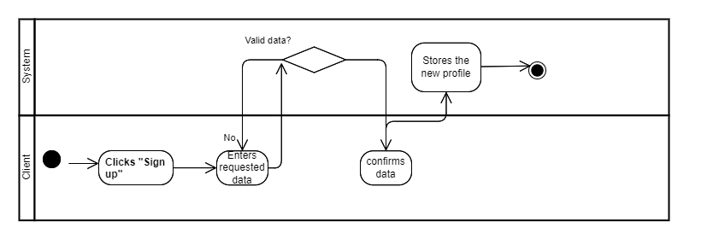

**Signing in**

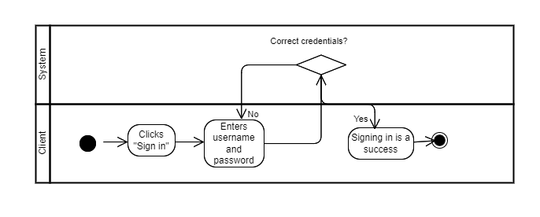

**Client talking to customer service**

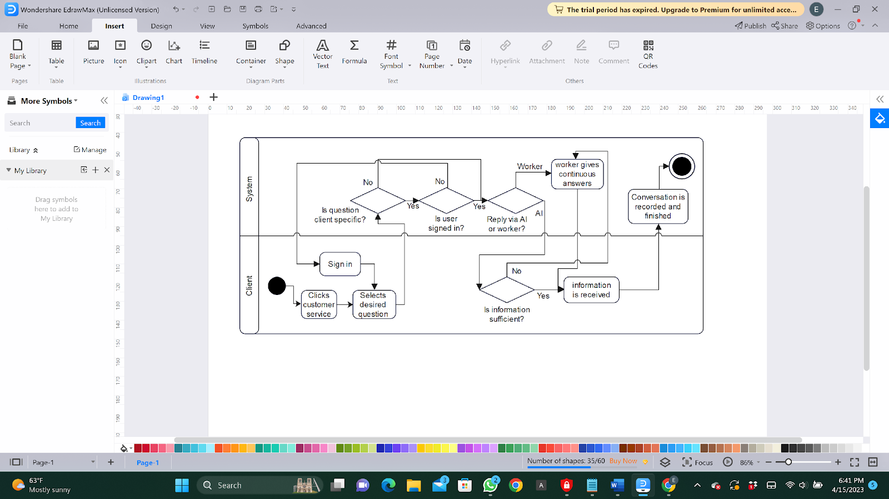

**Client adding to cart**

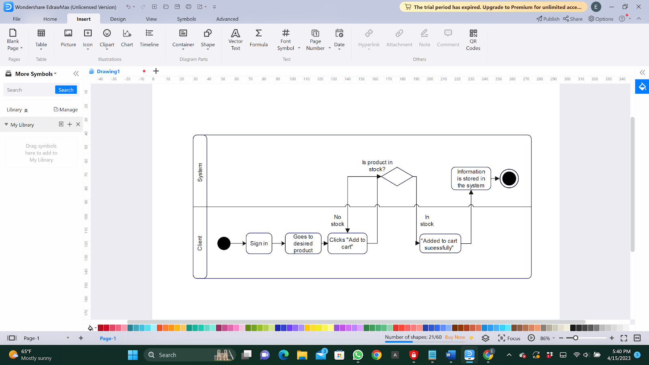

**Client Entering Giveaways**

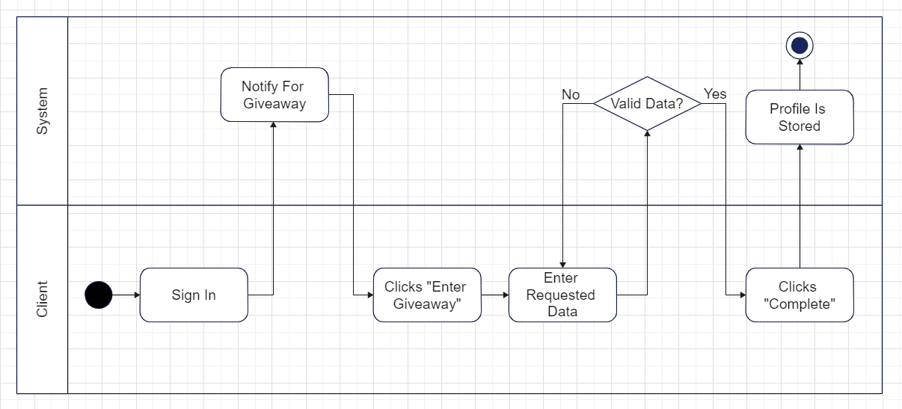

**Client requesting Personalizations**

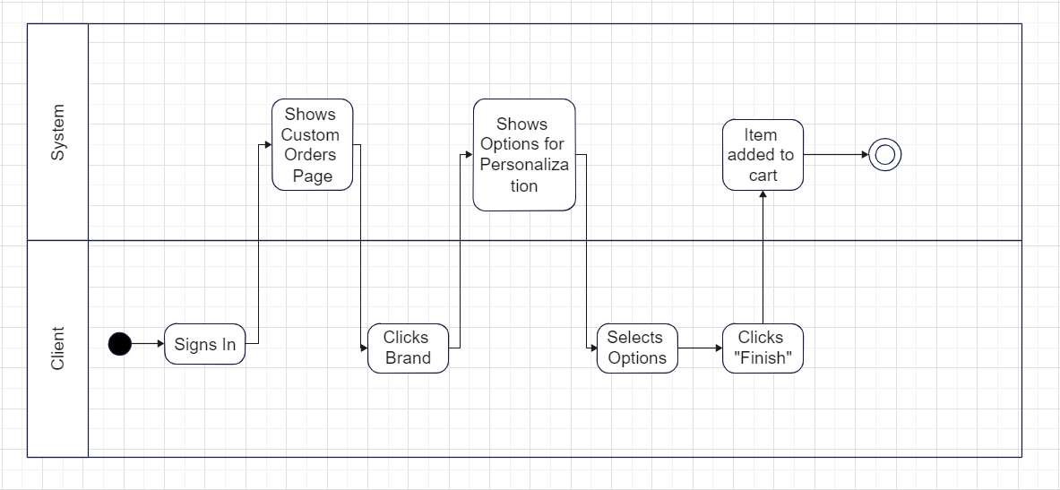

**Client making appointment with technician**

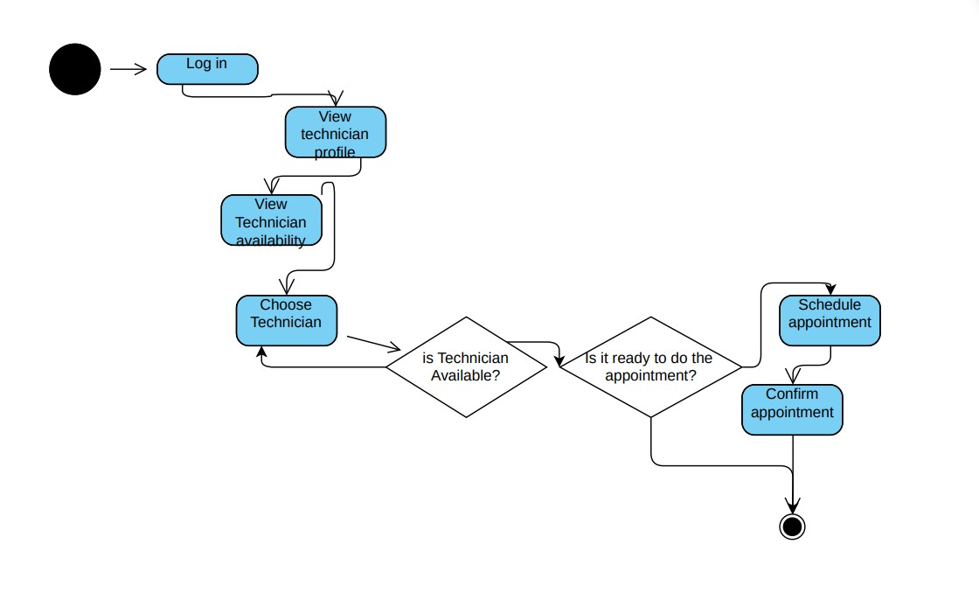

**Service Modification**

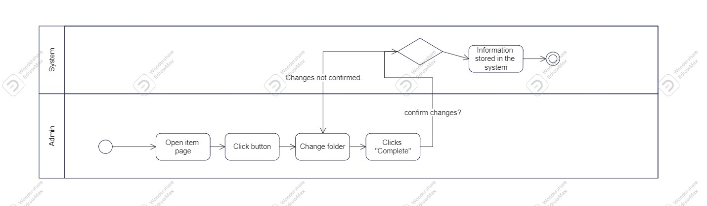

* 1. **State Diagrams**

**Client** 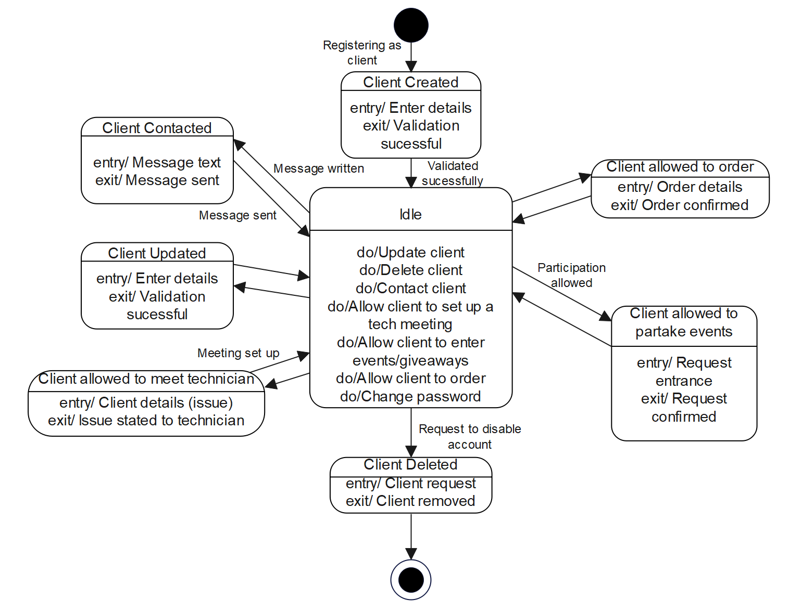

Technician

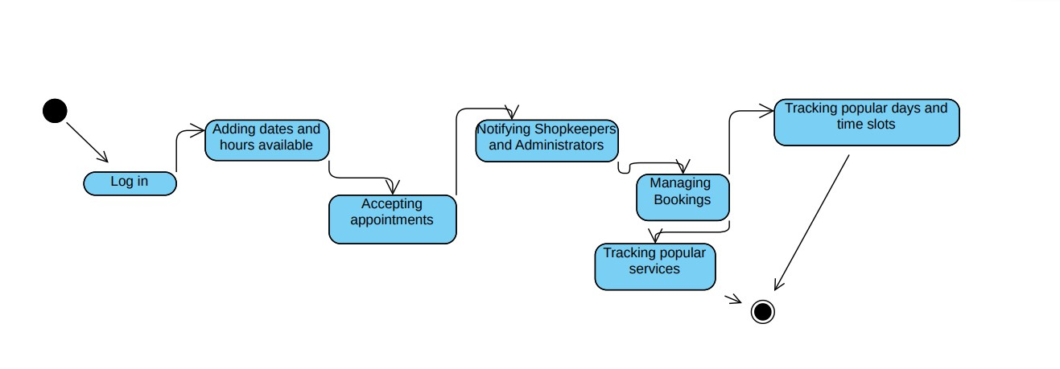

Admin

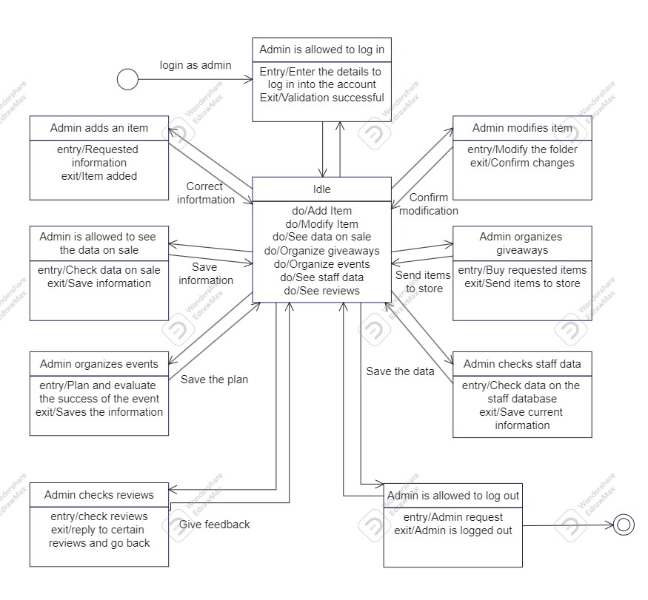

Client ordering

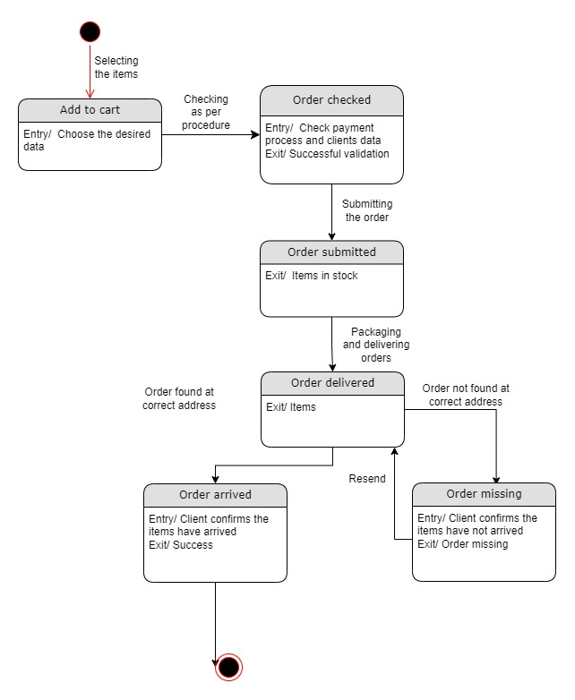

Client requesting personalization’s

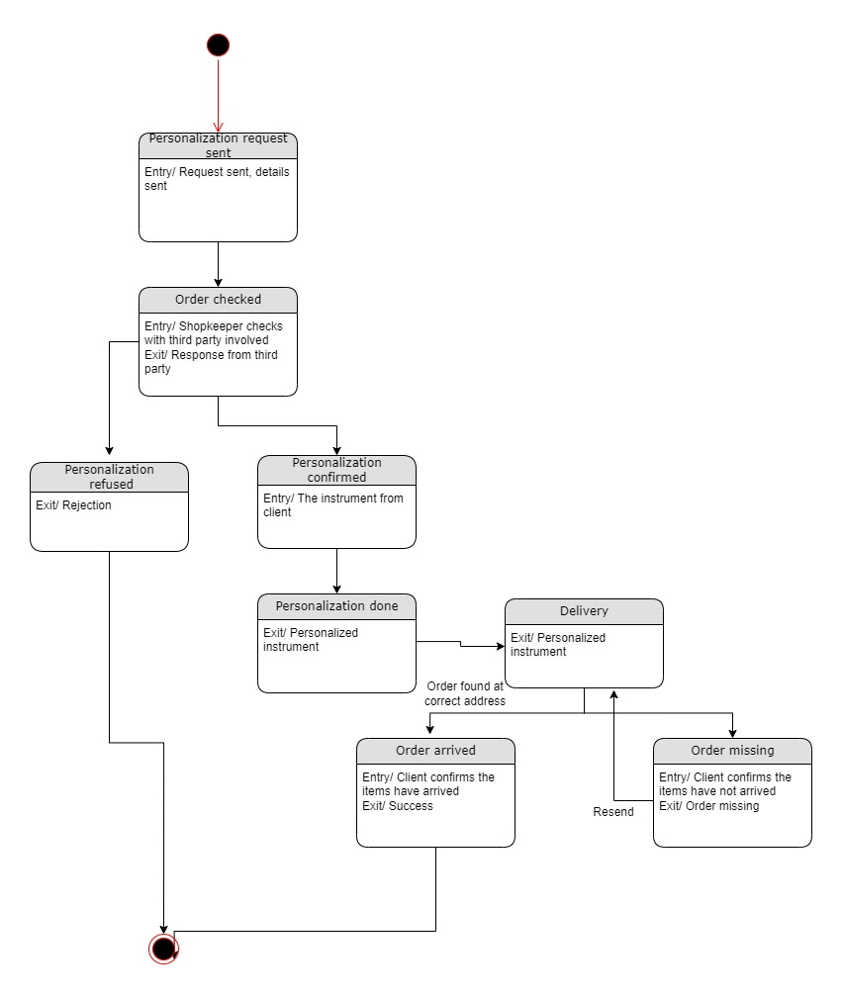

Payment

